|  |
| --- |
| EOMTOOL-034.1 |
| Partial Finalization |
| Currently campaigns are finalized all at once but we would like the option of finalizing on a per publisher basis. |

7/18/2012

# Implementation Details

## New column on workflow screen.

An additional column will be added to the workflow grids for both finalization and verification.

* Finalization (top): **#Pubs (Number needing to be Finalized)**
* Verification (bottom): **#Pubs (Number needing to be Verified)**

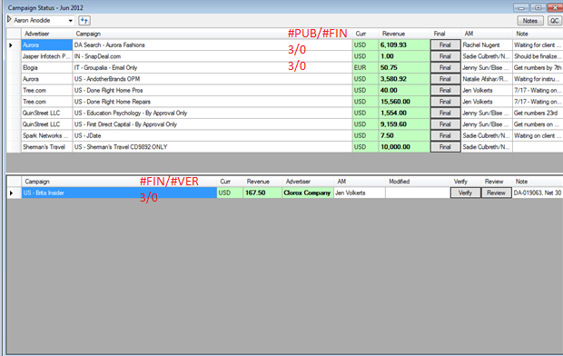

## Double click to open By Publisher Workflow Modal Dialog

Double clicking a row will open a model dialog which has essentially the same functionality as the current screen accept the Campaign column will be replace by the Publisher.

## By Publisher Workflow Screen

